Name **Alden Butzke**

**BA 355: Business Analytics, Case 4**

Use the FLC zip code data to answer the following questions:

1. How many students come to FLC from each state? List the top 10 states where FLC students come from (in order with, of course, Colorado first). List both the number of students and percentage of the total. Are there any states with no students attending FLC?

|  |  |  |
| --- | --- | --- |
| **Colorado** | **1711** | **24%** |
| **New Mexico** | **485** | **7%** |
| **Arizona** | **291** | **4%** |
| **California** | **147** | **2%** |
| **Alaska** | **110** | **2%** |
| **Oklahoma** | **105** | **1%** |
| **Texas** | **101** | **1%** |
| **Illinois** | **59** | **1%** |
| **Utah** | **36** | **1%** |
| **Iowa** | **34** | **0.5%** |

**No students from West Virginia**

1. Use the new Excel “Data Types: Geography” feature to estimate the populations of the 10 states from part a) above. Provide a list of these states and populations.

|  |  |  |  |
| --- | --- | --- | --- |
| **Colorado** | **1711** | **24%** | **5,695,564** |
| **New Mexico** | **485** | **7%** | **2,095,428** |
| **Arizona** | **291** | **4%** | **7,171,646** |
| **California** | **147** | **2%** | **39,557,045** |
| **Alaska** | **110** | **2%** | **737,438** |
| **Oklahoma** | **105** | **1%** | **3,943,079** |
| **Texas** | **101** | **1%** | **29,145,505** |
| **Illinois** | **59** | **1%** | **12,741,080** |
| **Utah** | **36** | **1%** | **3,161,105** |
| **Iowa** | **34** | **0.5%** | **3,156,145** |

1. For zip code **81301**, estimate/calculate how many miles each student ZIP Code is from 81301; there are hints online how to do this. List how many students were from the ranges below and the percentages of the total from each range, too. Don’t worry about the cumulative numbers, so list how many from 0-10, 10-25, 25-50, etc. The ranges are 10, 25, 50, 100, 250, 500, 1000 and 2000.



1. Redo c) but use a different zip code (your choice) for the home base zip code. What city is it? How does this affect the results?



**Anchorage, it flips the shape of the distribution and makes it left skewed**

1. Use a PivotTable on the distance data to determine where students are coming from. I think a group size of 50 might work, but use a better group size if you can find one. List how many students (and what percentage of students) come from each category – let’s say up to 1000 miles, unless there happens to be a big number somewhere after 1000.



1. Draw a graph using your results from part d). On the graph, see if you can identify which population centers cause big spikes in the data. For example, I think you’ll find a big spike between 200 and 250 miles due to the Front Range. Will you find a spike for Phoenix? Label all the spikes on the graph with the cities/population centers that cause them (you can do this by hand or on maybe on Excel). Make this graph really nice – I believe that it will explain FLC enrollment as well or better than the states/distance data.



1. Draw a map like below by inserting the data into the Map function on Excel. One state – spoiler alert, it’s Colorado -- will be too dark while all other too similar in color; figure out a way to adjust the input data to make the map more informative.

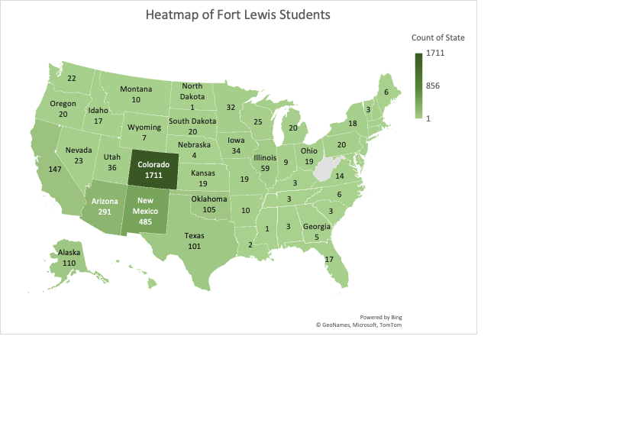

1. Write up your results in a couple of paragraphs combining everything from above.

Fort Lewis asked to see the student population segmented by distances from the college. In order to answer this question, student zip codes were used to calculate straight line distances from 81301, Durango, CO. It was found that 1711 students come from Colorado, 485 from New Mexico, and 291 from Arizona. These are the three most likely resident states of Fort Lewis students. Further, it was found that 24% of Fort Lewis students are from Colorado. Thus, as first, it seems imperative that Fort Lewis maintain its focus on in state students in order to drive enrollment.

However, it is important to consider that different states have different populations, and thus, states like California have an arbitrarily high enrollment at Fort Lewis when it could just be a second order effect of CA’s higher population. Indeed, this does mean that states with high populations should be ignored. Rather, it might instead indicate a state that could potentially increase enrollment. Considering this, Texas and California are two states with high populations that already comprise a significant proportion of students, that could be marketed to. In market terms, there is a bigger market and a higher propensity to capture market share.

Finally, it is important to consider the distance from Fort Lewis when considering viable geographies to market to. Texas is significantly closer to Durango than California, so it reduces a barrier to entry. Thus, Texas has a high amount of likely students, and should be prioritized if increasing enrollment is the first priority.

Taking a step further, it would be important to compare the cost of transportation as well as the distance. For instance, a flight from a big city in California might be cheaper than a 13 hr drive from Texas, and perhaps this means that California residents are equally viable potential students as Texans. Moreover, it would also be important to include the expected return of a student considering their resident state. Finally, the location of villages, reservations, and populations eligible for the tuition waiver would also likely be hotspots of students.